
PlanExpress – TPA Quick Guide

This guide provides an overview of PlanExpress, your primary tool for providing plan provision detail during the conversion process.

  - Launched via PartnerLink®
  - Guided Experience; index navigation with show/hide logic based on prior answers
  - Data mapped directly into Recordkeeping System
  - TPA Plan Installation Summary; summary document of TPA answers to Plan Installation Questionnaire

Website Access
After logging into PartnerLink, access PlanExpress via the PlanExpress link located under the Implementation menu on the PartnerLink tab.

Plan Access
On the PlanExpress menu select Option 2: Complete Plan Data. This option will take you to your available plan list. Only your plans will be available on the plan list or through the search function.

Site Navigation/ Functionality
Upon selecting a plan you will be taken to the Plan Installation Questionnaire index. From the index, you will be able to navigate through the questionnaire by clicking on any Page Title. You will also be able to progress through the questionnaire using the navigation buttons provided within each page.

- Mandatory Fields – Fields marked with a red vertical line are required and must be completed to save updates to the page.
- Case Sensitive – Fields are case-sensitive and will load into the Recordkeeping System as input.
- Navigation Buttons – Each page contains navigational buttons allowing you to 1.) save or skip changes made to a page and 2.) continue through the questionnaire to the next page, return to the questionnaire index or return to the PlanExpress menu.
- Help Instruction – Instructions on how to complete fields are included on several pages.
- Guided Experience – Guided user experience through show/hide logic by linking related questions. Subsequent questions will appear or hide based on how previous questions were answered.

Process Overview
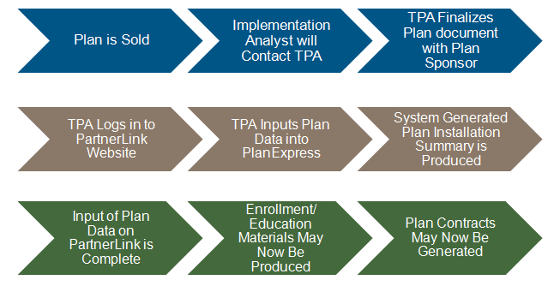

TPA Tools and Support
In moving from a paper TPA checklist to an online interface we offer additional tools and support to aid you in providing plan provision detail.

- TPA Plan Installation Summary – A TPA Plan Installation Summary will generate upon completion of the Plan Installation Questionnaire and be delivered to your email address on file. The summary can be used as a tool to review and confirm plan provisions as the content of the TPA Plan Installation Summary will be determined and generated by PlanExpress based upon the answers you provide in the Plan’s Installation Questionnaire. Additionally, this same information will be used to create the initial enrollment books and to build the plan on the Recordkeeping System.

- TPA Install Support Team – Implementation Services has a TPA support team available for PlanExpress training, questions and feedback. Please feel free to contact this group via email at GWF_TPA_Install_Support@gwrs.com.

During the conversion process you may also contact your assigned Implementation Analyst for assistance.

- TPA PlanExpress Training Deck – Additional detail and screen prints of the information provided in this quick guide is available in a PowerPoint presentation. A copy of the presentation can be obtained from your assigned Implementation Analyst, TPA Install Support Team or TPA Director.

Helpful Hints
Money Types – We recommend all money types, active and frozen, be confirmed and entered into PlanExpress prior to completing disbursement rule questions. If additional money types are added to PlanExpress after completion of the disbursement rule questions, the questionnaire will delete all values for these questions. The questionnaire is designed in this manner to guide the user back through the disbursement questions to capture the additional money types in order to better ensure the accuracy of the information provided.

Great-West FinancialSM refers to products and services provided by Great-West Life & Annuity Insurance Company (GWL&A), Corporate Headquarters: Greenwood Village, CO; Great-West Life & Annuity Insurance Company of New York (GWL&A of NY), Home Office: White Plains, NY; its subsidiaries and affiliates. The trademarks, logos, service marks, and design elements used are owned by GWL&A. (c)2013 Great-West Life & Annuity Insurance Company. All rights reserved. PT183521 (10/13)

