**Marketing Banner Submission Request**

Plan Level Request Site level Request

Plan Number(s)_________________________________________________________

Plan Name _____________________________________________________________

Requested by ________________________________ phone _____________________

Date to start display ________________ Date to terminate display _______________

1. **Upper right hand side rotating marketing banner (Post Login)**

Rotating marketing banners can accommodate text, hyperlinks, or images sized to the appropriate specifications. Images can be static (no action) or active (hyperlinked to documents or URLs). Hyperlink documents should be housed on a secure server (https:) to provide the best user experience. If providing a static document, attach the .pdf or word document to the request. Clearly identify documents/links and their position within the text.

**Text only display**

* Double wide (plans not using PRI tile)
  + Heading - 40 characters
  + Message - 485 characters including spaces (no paragraph breaks).
  + Text can include hyperlinks to documents provided by client.
    - Identify hyperlinks by bold/underlined text

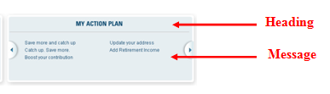

* Single wide (plans using PRI tile)
  + Heading – 20 characters
  + Message – 160 characters including spaces (no paragraph breaks).
  + Text can include hyperlinks to documents provided by client
    - Identify hyperlinks by bold/underlined text

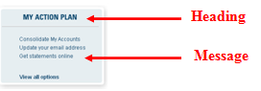

**Heading:**

**Message:**

Check this box if a linked document is accompanying the request.

Name of linked document ___________________________________________________________

**Image display**

* Size specifications:
  + Single wide 135 X 178 pixels
  + Double wide 412 X 135 pixels.
* Submitted in .jpg .png or .gif format
* Image should be high resolution web ready art.

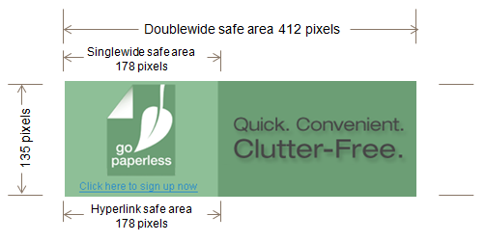

**Image:**

Include in this space or attach to request

Check this box if a linked document is accompanying the request.

Name of linked document ___________________________________________________________

1. **Modal Window message (post login)**

Post login pop-up modal will be displayed as soon as a participant authenticates login credentials and reaches the post login landing page. The modal window takes over the screen and requires users to click the (X) to acknowledge/close before additional action can be taken.

Modal windows can accommodate text, images, and hyperlinks.

Modal bulletins are shared between the desktop and mobile web application and will automatically show in both places. There is not a way to set them separately.

* Message set at site, plan, or participant level – provide plan/participant list if applicable
  + Heading – 85 characters including spaces
  + Sub heading (optional) – 250 characters including spaces
  + Message – 4000 characters including spaces
    - Identify hyperlinks by bold/underlined text
  + Image must be 220X220 pixels in size

Check this box if a linked document is accompanying the request.

Name of linked document ___________________________________________________________

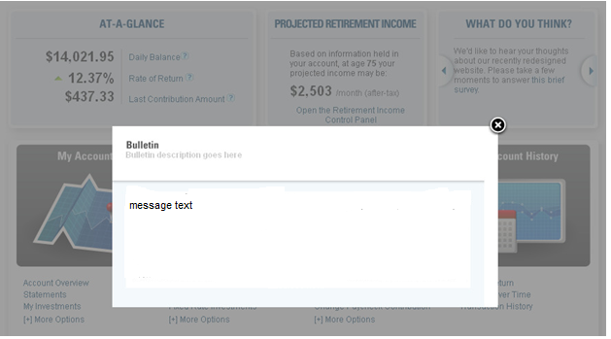

**Message**

**Sub-Heading**

**Heading**

**Provide a .pdf or word document mockup of the actual images and/or text to appear. This will be followed as reference for placement and positioning.**

1. **Mobile Web Application**

Post login rotating banner can be set at either the site level or plan level.

Mobile web app banners are separate from the desktop banners.

Banner specs:

* Characters with spaces: 450
* Image specs: 640 x 160 pixels at 72 dpi File formats: .eps, .psd, .png, .jpg, .gif

Reviewed By Partner Marketing Team : ____________________________________ Date: __________